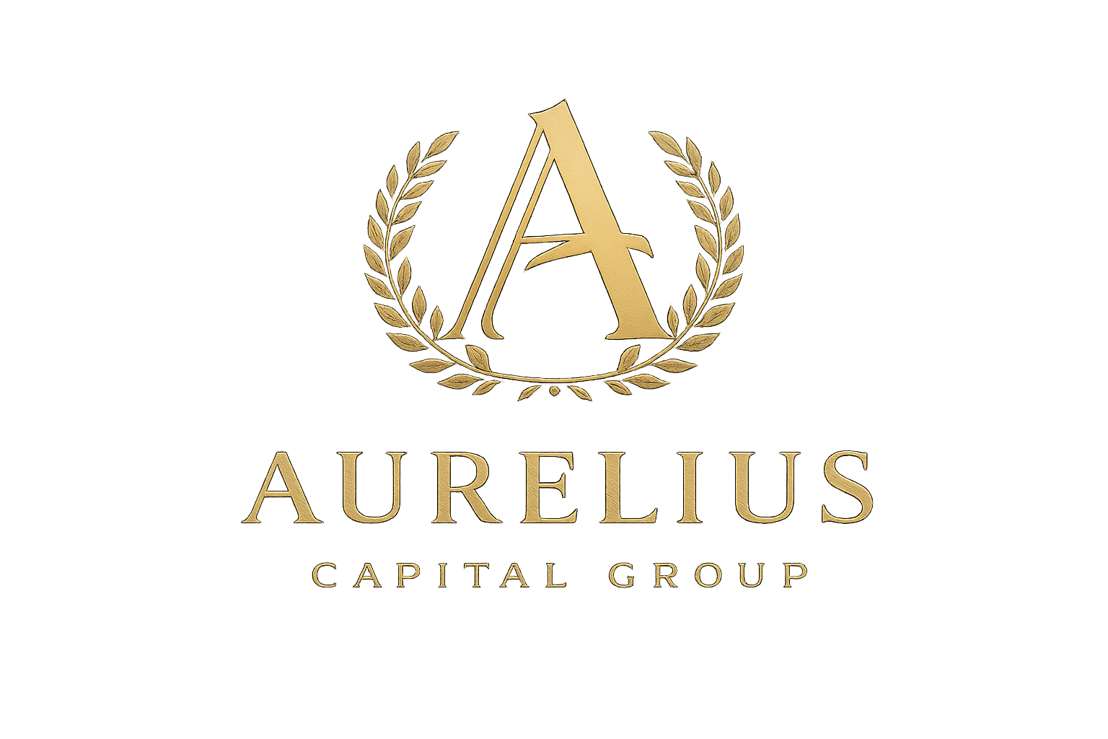

ASSET OWNER MANDATE AGREEMENT

==============================

ASSET ORIGINATION & INTRODUCTION AGREEMENT

This Asset Origination & Introduction Agreement (“Agreement”) is entered into as of [Effective Date], by and between:

Aurelius Capital Group OÜ, an Estonian private limited company (“ACG”),
and
[Asset Owner Legal Name], (“Owner”).

1. PURPOSE

Owner hereby appoints ACG to originate, screen, and introduce the commercial real estate asset described in Exhibit A (“Property”) to institutional tokenization platforms, capital structuring firms, and other qualified counterparties.

ACG’s role is strictly limited to non-custodial, non-binding introduction services.

2. SCOPE OF SERVICES

ACG may:

Screen the Property for institutional readiness

Prepare high-level asset summaries

Introduce the Property to selected third-party counterparties

Facilitate early-stage alignment discussions

ACG shall not:

Provide investment, legal, or tax advice

Issue securities or tokens

Custody funds or assets

Act as a broker-dealer or regulated intermediary

3. EXCLUSIVITY

☐ Exclusive ☐ Non-Exclusive (check one)

If exclusive, Owner shall not engage any third party to perform substantially similar services with respect to the Property during the Term.

4. SUCCESS-BASED COMPENSATION

4.1 Definition of Successful Transaction

A “Successful Transaction” means any transaction, consummated during the Term or within twelve (12) months thereafter, that results in liquidity, capitalization, or economic consideration related to the Property with any counterparty introduced, directly or indirectly, by ACG, regardless of form, structure, entity, timing, or consideration.

This includes, without limitation:

Token issuance

Capital raise

Structured equity placement

Partial sale or fractionalization

4.2 Cash Success Fee

Upon a Successful Transaction, Owner shall pay ACG a cash success fee equal to [●]% of the gross transaction value, payable at closing or concurrent with capital disbursement.

No Successful Transaction = no fee.

4.3 Optional Long-Term Alignment

By mutual written agreement executed prior to closing, ACG may retain a non-controlling equity or token allocation equal to [●]% of post-issuance units, in addition to or in partial substitution for the cash success fee.

Such allocation:

Confers no management or control rights

Imposes no fiduciary obligations

Shall be fully disclosed to all relevant parties

5. NON-CIRCUMVENTION

Owner shall not directly or indirectly circumvent ACG, including through affiliates, related parties, special purpose vehicles, successor entities, or alternative transaction structures.

Any transaction completed in violation of this provision shall be deemed a Successful Transaction for fee purposes.

6. CAUSATION PRESUMPTION

Introduction by ACG shall be presumed to be the proximate cause of any Successful Transaction unless Owner proves otherwise by clear and convincing evidence.

7. TERM

This Agreement shall remain in effect for [90–180] days, unless extended in writing.

8. OWNER REPRESENTATIONS

Owner represents and warrants that:

They have authority to transact

All information provided is accurate and complete

No undisclosed litigation or encumbrances materially affect the Property

9. CONFIDENTIALITY

All non-public information exchanged shall remain confidential unless disclosure is required by law.

10. GOVERNING LAW

This Agreement shall be governed by the laws of Estonia.

ASSET INTAKE & DISCLOSURE FORM

==============================

AURELIUS CAPITAL GROUP

Asset Intake & Disclosure Questionnaire

Asset Owner Legal Name:
Authorized Signatory:
Email / Phone:

SECTION A — PROPERTY OVERVIEW

Property Address:

Asset Type:

Estimated Market Value:

Year Built / Renovated:

SECTION B — OWNERSHIP & AUTHORITY

Legal Owner Entity:

Ownership % Held:

Are co-owner consents required? ☐ Yes ☐ No

Any ownership disputes? ☐ Yes ☐ No

SECTION C — FINANCIAL SUMMARY

Trailing 12-month NOI:

Occupancy Rate:

Major Tenants (% of income):

Known CapEx requirements:

SECTION D — DEBT & ENCUMBRANCES

Existing debt outstanding:

Lender(s):

Restrictions on equity transactions? ☐ Yes ☐ No

Liens or encumbrances? ☐ Yes ☐ No

SECTION E — LEGAL & REGULATORY

Pending litigation? ☐ Yes ☐ No

Environmental issues? ☐ Yes ☐ No

Regulatory violations? ☐ Yes ☐ No

If yes, explain fully.

SECTION F — OWNER OBJECTIVES

Desired liquidity amount:

% ownership to be structured/tokenized:

Target timeline:

SECTION G — REPRESENTATIONS & ACKNOWLEDGMENTS

Owner acknowledges and agrees that:

All information provided is accurate and complete

ACG relies exclusively on information provided by Owner

ACG does not independently verify information unless agreed in writing

Submission does not constitute approval, endorsement, or recommendation

Owner agrees to indemnify and hold harmless ACG from losses arising from materially false or misleading information provided herein.

Authorized Signature:
Name / Title:
Date:

MUTUAL NON-DISCLOSURE AGREEMENT

==============================

MUTUAL NON-DISCLOSURE AGREEMENT

This Mutual Non-Disclosure Agreement (“Agreement”) is entered into as of [Effective Date], by and between:

Aurelius Capital Group OÜ, and [Counterparty Name] (each a “Party”).

1. PURPOSE

The Parties wish to exchange confidential information solely to evaluate a potential business relationship related to commercial real estate origination, structuring, or tokenization (“Purpose”).

2. CONFIDENTIAL INFORMATION

“Confidential Information” includes all non-public information disclosed in any form relating to:

Assets

Financial data

Transaction structures

Business processes

Partner relationships

3. OBLIGATIONS

Each Party agrees to:

Maintain confidentiality

Use information solely for the Purpose

Limit disclosure to personnel with a need to know

4. EXCLUSIONS

Confidential Information does not include information that:

Is publicly available

Was independently developed

Is required to be disclosed by law

5. RESIDUAL KNOWLEDGE

Nothing herein restricts either Party from using residual knowledge retained in unaided memory, provided no Confidential Information is intentionally disclosed.

6. NO EXCLUSIVITY

Nothing in this Agreement creates an exclusive relationship or restricts either Party from engaging in similar discussions with third parties.

7. LIMITATION OF INJUNCTIVE RELIEF

Injunctive relief shall be limited solely to preventing unauthorized disclosure and shall not restrict lawful business operations.

8. TERM

This Agreement shall remain in effect for three (3) years, with confidentiality obligations surviving termination.

9. GOVERNING LAW

This Agreement shall be governed by the laws of England and Wales.

